AGGARWAL COLLEGE BALLABGARH
Class-B.Sc.1st Year
Computing Fundamental and C Programming
(Acc. to NEP 2020 B.Sc.1st sem)

WEEK -1
1. WAP to convert number from Decimal to Binary.
2. WAP to check whether number is Palindrome or not.
3. WAP to swap two numbers without using third variable.
WEEK -2
4. WAP to check whether a number if Armstrong or not.
5. WAP to find factorial of a number.
6. WAP to check whether number is Perfect Square or not.
WEEK -3
7. WAP to find SUM and AVERAGE of two numbers.
8. WAP to convert temperature from Fahrenheit to Celsius and Celsius to Fahrenheit.
9. WAP to read and print an employee's detail using structure.
10. WAP to check whether a number if Even or Odd.
WEEK -4
11. WAP to print all leap years from 1 to N.
12. WAP to print tables of numbers from 1 to 20.
13. WAP to print star/pyramid series.
14. WAP to convert temperature from Celsius to Fahrenheit and vice versa.
WEEK -5
15. WAP to convert number from Binary to Decimal.
16. WAP to print ASCII Table.
17. WAP to check whether a given number is palindrome or not using Bitwise Operator
18. WAP to count number of bits set to 1 in an Integer
WEEK -6
19. WAP to check if all the bits of a given integer is one (1)
20. WAP to find the Highest Bit Set for any given Integer
21. WAP to Count the Number of Trailing Zeroes in an Integer
22. WAP to find the Biggest Number in an Array of Numbers using Recursion
WEEK -7
23. WAP to accept Sorted Array and do Search using Binary Search
24. WAP to Cyclically Permute the Elements of an Array
25. WAP to print the sum and product of digits of an integer.
26. WAP to reverse a number.
WEEK -8
27. WAP to compute the sum of the first n terms of the following series
S = 1+1/2+1/3+1/4+......
28. WAP to compute the sum of the first n terms of the following series
S =1-2+3-4+5................
29. Write a function that checks whether a given string is Palindrome or not. Use this function to find
whether the string entered by user is Palindrome or not.
30. Write a function to find whether a given no. is prime or not. Use the same to generate the prime numbers less than 100.
WEEK -9
31. WAP to compute the factors of a given number.
32. Write a macro that swaps two numbers. WAP to use it.
33. WAP to print a triangle of stars as follows (take number of lines from user):
*
***
*****
*******
*********
34. WAP to perform following actions on an array entered by the user:
i) Print the even-valued elements ii) Print the odd-valued elements
iii) Calculate and print the sum and average of the elements of array
iv) Print the maximum and minimum element of array
v) Remove the duplicates from the array vi) Print the array in reverse order
The program should present a menu to the user and ask for one of the options. The menu should also
include options to re-enter array and to quit the program.
WEEK -10
35. WAP that prints a table indicating the number of occurrences of each alphabet in the text entered as
command line arguments.
36. Write a program that swaps two numbers using pointers.
37. Write a program in which a function is passed address of two variables and then alter its contents.
38. Write a program which takes the radius of a circle as input from the user, passes it to another function
that computes the area and the circumference of the circle and displays the value of area and
circumference from the main() function.
WEEK -11
39. Given two ordered arrays of integers, write a program to merge the two-arrays to get an ordered array.
40. WAP to display Fibonacci series (i)using recursion, (ii) using iteration
41. WAP to calculate Factorial of a number (i)using recursion, (ii) using iteration
42. WAP to calculate GCD of two numbers (i) with recursion (ii) without recursion.
43. WAP to design calculator with basic operations using switch.
WEEK -12
44. Write a program to find sum of n elements entered by the user. To write this program, allocate
memory dynamically using malloc() / calloc() functions or new operator.
45. Write a menu driven program to perform following operations on strings:
a) Show address of each character in string
b) Concatenate two strings without using strcat function.
c) Concatenate two strings using strcat function.
d) Compare two strings
e) Calculate length of the string (use pointers)
f) Convert all lowercase characters to uppercase
g) Convert all uppercase characters to lowercase
h) Calculate number of vowels
i) Reverse the string

AGGARWAL COLLEGE BALLABGARH
Class-B.SC.-2nd sem
Web Development-I
(Acc. to NEP 2020 B.Sc.2nd sem)

WEEK -1
1. WAP that explains the HTML style Attributes to specify the style properties for the HTML
element.
2. WAP that illustrates the HTML heading tags.
3. WAP that illustrate the use of <p> and <hr> HTML tags
WEEK -2
4. WAP that illustrate the use of different text formatting HTML tags
5. WAP that illustrate the use of RGB color values to style our html elements.
6. WAP that Creating a simple table in HTML using a table tag
WEEK -3
7. WAP that demonstrates an ordered list (<ol>) with five programming languages listed sequentially, each item numbered automatically by the browser.
8. WAP for Implementation of Unordered List horizontally.
WEEK -4
9. WAP that illustrate the use of CSS color, font family and font size properties.
10. WAP that illustrate the use CSS Table properties.
11. WAP to create a 3D Groove border using CSS.
WEEK -5
12. WAP to dynamically change color by percentage CSS.
13. WAP to set the order of the flexible items using CSS.
14. WAP to create reflection effect using HTML and CSS.
WEEK -6
15. WAP to create Image Folding Effect using HTML and CSS.
16. WAP to design a Parallax Webpage using HTML & CSS.
17. WAP to create RGB color generator using HTML CSS and JavaScript.
18. WAP to use Google material icon as list-style in a webpage using HTML and CSS.
WEEK -7
19. WAP to design a calendar using HTML and CSS?
20. WAP to design Background color changer using HTML CSS and JavaScript.
21. WAP to create Image Stack Illusion using HTML and CSS.
WEEK -8
22. WAP to create Hover animations on Button.
23. Create a web page that contains the image of a human. Form an image map such that the user clicks on any part of the body, a web page showing information on that part of the body is displayed.
24. Create a registration form for your institution which will ask first name, last name, age, sex, date of birth, class, address, contact number, email id from the candidate. When you submit the form it should display the confirmation message that “You details are saved” (use JavaScript for displaying the confirmation message).
WEEK -9
25. Create an HTML page with a paragraph. Apply a style directly using inline styles to change the color and font size. Then use internal CSS to change the background color of the paragraph.
26. Create a nested HTML structure (e.g., a <div> containing a <p> and an <a>). Apply CSS styles to the parent <div> and observe how styles are inherited by child elements. Modify styles on child elements to see how inheritance works.
27. Create a webpage that includes an iframe displaying another webpage. Ensure the iframe has a set width and height, and add a border around it.
WEEK -10
28. Create an HTML page and use different types of CSS selectors (universal, type, class, ID, attribute, descendant, child, sibling). Apply styles using these selectors and Design an HTML table and use CSS to style it. Apply borders, padding, background colors, and hover effects
29. Create an HTML page with a background image and a foreground text. Use CSS to set the opacity of the background image .
30. Design an HTML page with overlapping elements. Use CSS to apply different z-index values to control the stacking order of the elements.
31. Create a HTML form that has number of Textboxes. When the form runs in the Browser
fill the textboxes with data. Write JavaScript code that verifies that all textboxes has been filled.
If a textboxes has been left empty, popup an alert indicating which textbox has been left
empty.
WEEK -11
32. Create an HTML page and use CSS media queries to apply different styles for different screen sizes (e.g., mobile, tablet, desktop).
33. Create a form having number of elements (Textboxes, Radio buttons, Checkboxes,and so
on). Write JavaScript code to count the number of elements in a form
34. Write a JavaScript program that creates an array of 5 numbers. Use array methods to add a number to the end, remove a number from the beginning, and find the index of a particular number.
35. Write a JavaScript function that changes the background color of a div element when a button is clicked. Provide multiple buttons to change to different colors.

BSc(CS) 2nd Sem
Object Oriented Programming using C++ (24CSCM402DS01)

WEEK-1
1. Write a program in C++ to find the area and circumference of a circle.
2. Write a program to display the size of different data types available in C++.
3. Write a C++ program to swap two numbers without using a third variable.
WEEK-2
4. Write a program to find max number among the given three numbers using if-else statement.
5. Write a program to convert decimal numbers to binary number using loop.
6. Write a program to print the Fibonacci series up to the given number of terms.
WEEK-3
7. Write a program to find whether a number is palindrome or not.
8. Write a C++ program to find area of a triangle, square, circle, rectangle using switch statement
WEEK-4
9. Write a program to print reverse the order of elements of an array and also print their sum.
10. Write a program to count positive and negative numbers using a while loop.
11. Write a program to merge ascending and descending array into the third array.
WEEK-5
12. Write a program to compare two strings without using any inbuilt function.
13. Write a program for count words in given string including spaces between words.
WEEK-6
14. Print Fibonacci series in C++ using user defined function.
15. Write a program to swap two numbers without using a third variable using functions.
16. Write a program to find the number is even or odd using pointer.

WEEK-7
17. Write a program to read infinite numbers and then arrange them in ascending order using a pointer.
18. Write a program to convert infix to postfix expression.
WEEK-8
19. Write a program to illustrate dynamic memory allocation.
20. Write a program to use new and delete operators for arrays.
WEEK-9
21. Write a program illustrating use of different constructors.
22. Write a program to read and print student's information using two classes and simple inheritance.
23. Write a program to demonstrate example of multilevel inheritance.
WEEK-10
24. Write a program to read and print employee information using multiple inheritance.
25. Write a program to demonstrate example of hierarchical inheritance to get square and cube of a number.
26. Write a program to overload sum( ) function.
WEEK-11
27. Write a program to overload ++ operator when used as prefix.
28. Write a program to demonstrate function overriding and virtual functions.
WEEK-12
29. Write a program using different file handling operations:
a) Opening and closing a file
b) Checking file for error
c) Read from a file
d) Write to a file
e) Append to a text file
30. C++ Program to demonstrate use of templates for the generic programming.

Aggarwal College, Ballabgarh
Class-B.Sc. 3rd sem
Subject- Programming in C++

WEEK -1
- WAP to calculate the compound interest for the entered value of principal, period and rate.
- WAP to print the following output
1
2 2
3 3 3
4 4 4 4
5 5 5 5 5
- WAP to calculate the root of a quadratic equation.
2x² + 4x +15
WEEK -2
- WAP to represent a Prime no. Series
1 2 3 5 7 11 13 ………
- WAP to display Fibonacci series upto entered n numbers.
- WAP to find the largest among entered n numbers.
12,34,55,0,11,77,100,2,4,5
WEEK -3
- WAP to calculate the multiplication of two matrices.
2 5 6 4 7 8
4 7 3 * 2 6 0
2 5 2 0 1 5
- WAP to calculate the addition of above two matrices.
- WAP for implementing an inline function .

WEEK -4

- WAP for illustrating scope resolution operator.
- Write a function power() to raise a number m to a power n. The function takes a double value for m and int value for n and returns the result correctly. Use a default value of 2 for n. Write a main that gets the values of m and n from the user.
- WAP for implementing friend function using two classes.

WEEK -5
- WAP for using object as function arguments(e.g. Adding hours and minute in the class time)
- WAP for returning objects as addition of two Complex numbers.
4+5i and 7+9i
- Define a class to represent a bank account. Include the following members:
Data members
- Name of depositor
- Account number
- Type of account
- Balance amount in the account
Member functions
- To assign the initial values.
- To deposit an amount.
- To withdraw an amount after checking the balance.
- To display name and balance.
WEEK -6
- WAP for implementing a constructor.
- WAP for implementing all types of constructor.
- WAP for dynamic initialization of constructor.
- WAP for implementing destructor.

WEEK-7

- WAP for unary minus operator overloading.
- WAP for binary operator overloading.
- WAP for overloading of operator using friend function.

WEEK -8

- WAP for implementing single inheritance.
- WAP for implementing multilevel inheritance.
- WAP for implementing multiple inheritance.
- WAP for implementing hybrid inheritance.
WEEK -9
- WAP for implementing the concept for virtual base class.
- WAP for deriving constructor in the derived class.
- WAP for implementing virtual functions.

WEEK -10

- WAP for illustrating the use of THIS pointer.
- WAP for illustrating pointer to object.
- WAP for array of pointer to object.
- WAP for pointer to derived object.
WEEK -11
- WAP for implementing compile time polymorphism.
- WAP for implementing run time polymorphism.
- WAP for working with multiple files.

WEEK -12

- WAP for working with class template.
- WAP for working with function template.
- WAP for function template with multiple parameter.
- WAP for member function template.

WEEK -13

- WAP for exceptional handling by try catch and throw statement.
- WAP for implementing multiple catch statement.
- WAP for implementing rethrowing an Exception.

WEEK -14

For revision and Practical file.

Aggarwal College,Ballabgarh
Class-B.Sc. 4th sem
Subject- C++, Data Structure
PROGRAMMING USING C++

WEEK -1
- WAP to calculate the compound interest for the entered value of principal, period and rate.
- WAP to print the following output
1
2 2
3 3 3
4 4 4 4
5 5 5 5 5
- WAP to calculate the root of a quadratic equation.
2x² + 4x +15
WEEK -2
- WAP to represent a Prime no. series
1 2 3 5 7 11 13 ………
- WAP to display Fibonacci series upto entered n numbers.
- WAP to find the largest among entered n numbers.
12,34,55,0,11,77,100,2,4,5
WEEK -3
- WAP to calculate the multiplication of two matrices.
2 5 6 4 7 8
4 7 3 * 2 6 0
2 5 2 0 1 5
- WAP to calculate the addition of above two matrices.
- WAP for implementing an inline function .

WEEK -4

- WAP for illustrating scope resolution operator.
- Write a function power() to raise a number m to a power n. The function takes a double value for m and int value for n and returns the result correctly. Use a default value of 2 for n. write a main that gets the values of m and n from the user.
- WAP for implementing friend function using two classes.

WEEK -5
- WAP for using object as function arguments(e.g. adding hours and minute in the class time)
- WAP for returning objects as addition of two Complex numbers.
4+5i and 7+9i
- Define a class to represent a bank account. Include the following members:
Data members
- Name of depositor
- Account number
- Type of account
- Balance amount in the account
Member functions
- To assign the initial values.
- To deposit an amount.
- To withdraw an amount after checking the balance.
- To display name and balance.
WEEK -6
- WAP for implementing a constructor.
- WAP for implementing all types of constructor.
- WAP for dynamic initialization of constructor.
- WAP for implementing destructor.

WEEK-7

- WAP for unary minus operator overloading.
- WAP for binary operator overloading.
- WAP for overloading of operator using friend function.

WEEK -8

- WAP for implementing single inheritance.
- WAP for implementing multilevel inheritance.
- WAP for implementing multiple inheritance.
- WAP for implementing hybrid inheritance.
WEEK -9
- WAP for implementing the concept for virtual base class.
- WAP for deriving constructor in the derived class.
- WAP for implementing virtual functions.

WEEK -10

- WAP for illustrating the use of THIS pointer.
- WAP for illustrating pointer to object.
- WAP for array of pointer to object.
- WAP for pointer to derived object.
WEEK -11
- WAP for implementing compile time polymorphism.
- WAP for implementing run time polymorphism.
- WAP for working with multiple files.

WEEK -12

- WAP for working with class template.
- WAP for working with function template.
- WAP for function template with multiple parameter.
- WAP for member function template.

WEEK -13

- WAP for exceptional handling by try catch and throw statement.
- WAP for implementing multiple catch statement.
- WAP for implementing rethrowing an Exception.

WEEK -14

For revision and Practical file.

Data Structure -I

Week 1:

Q1) Write a C program that prints below shape of triangle using nested loop

*****
****
***
**
*

Q2) Write a C program that prints below shape of rectangle using nested loop

*********
*********
*********
*********
*********

Q3) Write a C program that prints below shape using nested loop

*
**
***
****
*****
*****
****
***
**
*

Week 2:

Q4) Write a program to implement Linear Array with insertion and Deletion Operations

Q5) Write a program to find the smallest number from an Array.

Q6) Write a program to find the biggest number from an array.

Week 3:

Q7) Write a program to convert Decimal number to its equivalent Binary number.

Q8) Write a program to find transpose of an array of order m x n.

Q9) Write a program to find the first and second largest number of an array.

Week 4:

Q10) Write a program to Arrange Array elements in Ascending order.

Q11) Write a program to Marge two linear arrays.

Q12) Write a program to reverse array elements

Week 5:

Q13) Write a program to read a line of text using getchar function.

Q14) Write a program to read and write multiple lines of characters using arbitrary character to end inputting.

Q15) Write a program to reverse a given string.

Week 6:

Q16) Write a program to conut the number of characters, words and lines in a text.

Q17) Write a program to check weather a given string is a palindrome or not.

Q18) Write a program to convert a string to uppercase.

Week 7:

Q19) Write a program to implement 2D Array.

Q20) Write a program to Add Two 2D Arrays.

Q21) Write a program to find Multiplication of two 2D Arrays.

Week 8:

Q22) Write a program to implement stack using array. Use functions to write Push and Pop operations of stack.
Q23) Write a program to calculate factorial of a given number.
Week 9:

Q24 ) Write a program to convert an infix expression in to prefix expression.
Q25) Write a program to convert an infix expression in to postfix expression.
Q26) Write a program to convert postfix expression in to infix expression.
Week 10:
Q27) Write a program to implement Queue using array . Use functions to write insertion and deletion operations.
Q28 ) Write a program to implement Circular Queue.
Week 11:
Q29 ) Write a program to implement linear linked list using pointers.
Q30 ) Write a program to implement Circular linked list using pointers.
Week 12:
Q31 ) Write a program to implement Doubly linked list using pointers.
Q32) Write a program to implement Stack Using linear linked list .
Q33) Write a program to implement Queue Using linear linked list.

Aggarwal College, Ballabgarh
Class-B.Sc.5th sem
Subject-HTML , SQL
WEEK 1
- Apply formatting tags(bold, italic ,underline) on the below paragraph:-
- Apply paragraph tags (<p>),break tag(<br>)on below paragraph:-
- Give title and heading to your documents.(title=First program of H TML, heading= My first program).

A history of every thing
It start with a bang. Then everything inflates like a super balloon tieds up with super-strings, until the whole mess curdles into millions of milky ways. Starlight hits the volcanic rocks, and cooks up some tasty double-helix treats. They get eaten by each other, the fittest survive, a meteor kills the big ones and when it all freezes over the smart ones move into caves and start a fire
Wonders of the World
Vacations are not cheap. But who needs them anymore, with so many live cameras connected to the World Wide Web? Pack a picnic, and you can visit spacious pastures in allowed, New Jersey or the more scientifically minded at IBM’s Alma den Research Center. Or if it’s scenery you’re after adventure to ta half payer backyard in Fremont California.
Week 2
- Apply heading tags(h1,h2,h3,h4,h5.h6) on the following line:
I love my India I am proud on my India.
- Change font face, color ,size , alignments on the above paragraph:-
- Apply <pre> tag on the marks of 5 student in a following format:-
Stud roll stud name sub1 sub2 sub3 sub4 sub5 total %age
Week 3
- Apply Definitions are indented with respect to the terms.
Banana
A tropical yellow fruit
Apple
One a day keeps the doctor away
Lemon
Basis of lemonade
2. Insert an image by using suitable path of the image on your html documents like:-
<IMG SRC="protocol://server:port/path/filename.ext" WIDTH="#" HEIGHT="#">

Week 4
1. Create order and unordered list by using html tags on the below elements:-
- Vehicals
- Two wheelers
                - Bike
                - Bicycle
- Companies of two wheelers
- Three wheelere
- Auto
- Companies of three wheelers
- Four wheelers
- Car
- Companies of four wheelers
You should create more than that list like fruits, electrical equipment’s etc. And add at least five entries in each part of list.
2. Make a documents by using <small>,<big>,<sup>,<sub> , <strike>, <strong> tags on the following paragraph:-
New^{super}strength H₂O plus will strike out any stain, big or small. Look for new ^{super} strength H₂O plus in a stream near you.
Week 5
- Insert an background image and color on your document by using the following tag:-
<body background=”filename or URL”>
- Apply marquee tag on the following points:-
1. Make a conference alert
2. Make an admission alert (form date ,submission date, last date of submission of the form).
3. Any breaking news flash about your document.
4. Fresh results announcements and give an link page.
5. New roll no. Issue to the students of BCA class .
Also give an alignment like up, down, left or right.
Week 6
- Create link from one page from another by the following code on the all above marquee alerts:-
<a href=”filename.html”>admission alert symbol</a>
Week 7
1.create a table according to BASIC TABLE
This table:
Row 1, Col.1 | Col. 2 | Col. 3 | Col. 4
Row 2 | Aaa | Bbb | Ccc
Row 3 | Ddd | Eee | Fff

Is produced by this code:
<TABLE BORDER="1" CELLPADDING="4" CELLSPACING="0" BGCOLOR="#FFFF66">
<TR><TH>Row 1, Col.1</TH><TH>Col. 2</TH><TH>Col. 3</TH><TH>Col. 4</TH></TR>
<TR><TD>Row 2</TD><TD>aaa</TD><TD>bbb</TD><TD>ccc</TD></TR>
<TR><TD>Row 3</TD><TD>ddd</TD><TD>eee</TD><TD>fff</TD></TR>
</TABLE>
Where:
<TABLE> starts the table | </TABLE> ends the table
<TR> starts a row | </TR> ends a row
<TH> makes a column header | </TH> ends a column header
<TD> starts a column | </TD> ends a column
By default:
- A column header, <TH>, is displayed in bold and centered
- A regular cell entry, <TD>, is left aligned and in plain text, and
- The contents of cells in a row will be aligned vertically to the middle of the row from top to bottom.

Create atleast 10 rows and 10 columns in a table and make two tables as results of the students and a table of employees (at least 10 records in each table).

Note:- use alignment in tables like center, left or right.

Week 8
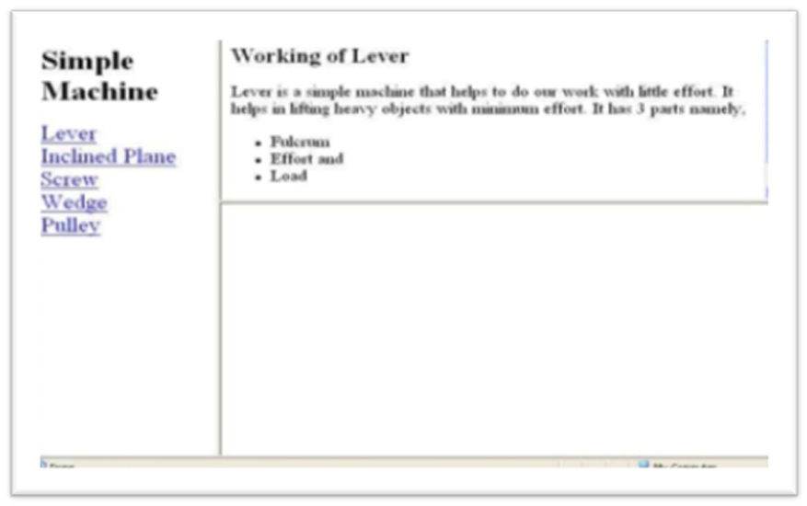
- Make frames on your document as per the above image.
Week 9
- Make admission form for college, job description form .
Week 10
- Make website on one of the following or as per your choice topics:
- Solar system
- Hospital management system
- Library management system
- Hotel management
- Flight reservation system
- Bank
- Departmental store
- Railway reservation
- Incredible india
- Customer care system on any of “ e based system.
Week 11-12
- Preparing of web site and revision of various tags.

AGGARWAL COLLEGE BALLABGARH
Class-B.Sc. 6th sem
Visual Basic
WEEK 1

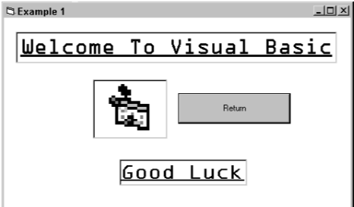

- Use the properties window to set
– M a i n f r am a s t h e f o r m n a m e .
– M y p r o g r a m s a st h e c a p t i o n .
– B a c k C o l o r t o W h i t e .
– B o r d e r S t y l e t o F i x e d S i n g l e .
– W i n d o w S t a t e t o M a x i m i s e d .
- Find the Menu icon and click on it to select it. Enter the following menu headings: Quit Introduction with indented subheadings of
Example 1
Click on Quit menu heading and enter the following code. This procedure is used to exit from running the project display and return to the design screens.
Private Sub Quit_Click()
Unload me
End Sub

Week 2

- Use the <F5> function key to run the application to verify that the Menu structure is correct and that the Quit procedure is free from error.
Set the following form properties:
- Form name as Welcome caption to Example1
- Backcolor to White
- Borderstyle to Fixed Single
- Windowstate to Maximised
- Click on the Example 1 main menu heading and enter the following code:
Private Sub Example1_Click()
Welcome.Show
End Sub
- Save your work and run <F5> to ensure that it is free of errors.
- Add two labels, an image and a command button to create a welcome screen.
- Select label icon from the toolbox. Click towards the centre-top of your form and position and resize your label as required.

With the label selected, use the properties window to
- Change the caption to WELCOME TO VISUAL BASIC
- Choose a bright back colour
- Set the font (Arial, underline, alignment centred, size 24 point, forecolour blue)
- Repeat to add the Enjoy label.
- Use the image icon on your toolbox to add the image to your form. Use the
- Properties window of the image to select a picture.
- Use the file menu to save your work and use <F5> to run the application.
- DON’T FORGET TO SAVE (AND BACK UP TO FLOPPY) ALL YOUR WORK.

Week 3
- Op e n a n e w f o r m a n d c h a n g e i t sn a m e t o C o l o u r C h a n g e r . P l a c e t h e f o l l o w i n g o b j e c t s on this form.

- A heading label2 (Caption = Colour Changer)
- 3 horizontal scroll bars (Set the max value property of all three to 255)
- 3 other labels (2red, 3Green, 4Blue)
- A command button to quit the form (Caption = Return)
- Another small label5 under the button with its visible property set to false.

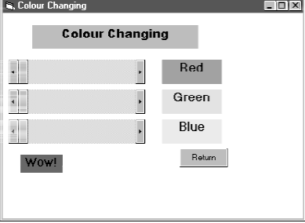

- D o u b l e c l i c k e a c h s c r o l l b a r a n d a d d t h e f o l l o w i n g c o d e t o i t s _ o n
C h a n g e ( ) e v e n t . U s e
Cut and paste to make the task easier.
- Label1.backcolor = RGB(hscroll1.Value, hscroll2.Value, hscroll3.Value)
- Label5.backcolor = RGB(hscroll1.Value, hscroll2.Value, hscroll3.Value)
- Label1.forecolor = RGB(255 - hscroll1.Value, 255 - hscroll2.Value, 255 - hscroll3.Value)
- Label5.forecolor = RGB(255 - hscroll1.Value, 255 - hscroll2.Value, 255 - hscroll3.Value)
- Label5.Visible = True Label5.Caption = “WOW!”
- Label2.backcolor = RGB(hscroll1.Value, 0, 0) Label3.backcolor = RGB(0, hscroll2.Value, 0)
- Label4.backcolor = RGB)0, 0, hscroll3.Value)

- D o u b l ec l i c k t h er e t u r n b u t to n a n d a d d t h e f o l l o w i n g c o d e t o i t s _ o n C l i c k ( ) e v e n t
Unload Me

WEEK 4
Function is a segment of code that accepts zero, one or more arguments and returns a single result. Visual Basic includes many built-in functions (intrinsic functions). Some perform basic mathematical tasks. Others manipulate string data such as converting text to upper Case or lower Case letters. An argument is a value you pass to a function so the function has data to work with. Function names have parentheses at the end to hold the function arguments. Even if a function has no arguments, the parenthesis are required.

Two intrinsic functions include message boxes and input boxes.

Message and input boxes
Message and input boxes are intrinsic functions in Visual Basic 6.0 which allow the end user to interact with the program. Follow the instructions Add new form to menu at the end of Week 1 to create a new form with a menu heading on the main form.
Call this “Message and Input Boxes”
- Make the Form.Caption = “Message and Input Boxes”
- Put a label on the top of the form “Computer Conversation”. Underneath have a
Command button with the caption “Talk to me!” Name the command button cmdtalk.
- Double click the command button to add the following code sequence.

Private Sub cmdtalk_Click()
Dim strquestion As String
Dim intanswer As Integer
‘First you must declare your variables’
‘Then use the input and message box functions’
Strquestion = inputbox(“Type in your name!”, “Ebeneezer”) intanswer = msgbox(“Hello there” &strquestion, vbokcancel, “Chat”)
End Sub

- Add a return button, called cmdback as you did in the colourchanger, using the code

Private Sub cmdback_Click()
Form1.Show
End Sub

- Run your program using <F5>. Don’t forget to save your work. Here are some handy literals (values that don’t change). You don’t have to learn them as the help prompt supplies a drop down list as you start to type.

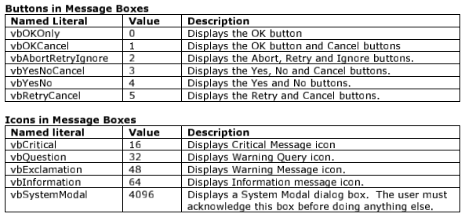

WEEK 5

Create a calculator that can add, subtract, multiply and divide two numbers given by the user.

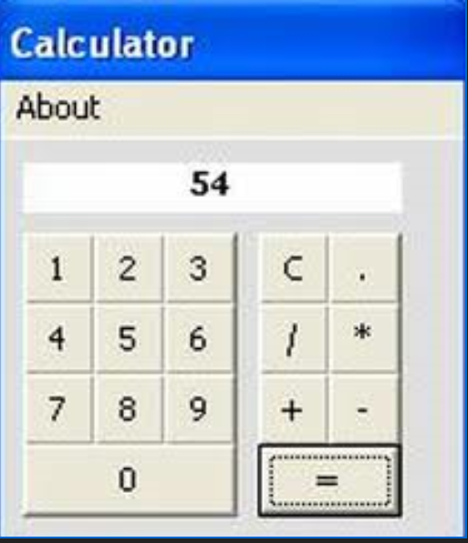

WEEK 6

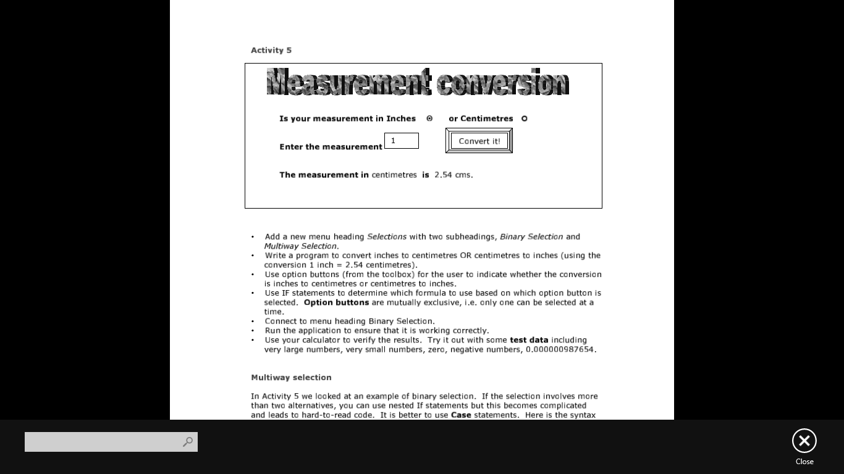

- Write a program to convert inches to centimetres OR centimetres to inches (using the conversion 1 inch = 2.54 centimetres).
- Use option buttons (from the toolbox) for the user to indicate whether the conversion is inches to centimetres or centimetres to inches.
- Use IF statements to determine which formula to use based on which option button is selected. Option buttons are mutually exclusive, i.e. Only one can be selected at a time.

WEEK 7
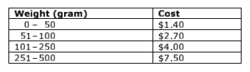

Design a project that allows a user to enter the weight in a text box and calculate the postage. Use Case statements in your code. Link this as caseweights under the Multiway menu heading in your main form.

WEEK 8
Create a program to generate the first 20 Fibonacci numbers. This time use a counter to control the number of iterations. By using For Loop, Do While Loop, While Loop.

WEEK 9
Writean event procedure to perform the following in vb:
- Reverse a string
- Determine whether the given string is palindrome
- Change the case of a string to upper or lower.

WEEK 10
Create a menu with the following menu optins:
- Style(which includes bold, italic and underline)
- Colour (which includes blue, green and red)
- Change Case (which includes uppercase, lowercase).

WEEK 11-12
Write a VB program to create a product table and to perform the following database operation :
- Insert the records
- Delete the records
- Update the records

